**Set up Android Studio and build a basic Android project that displays "Hello World" on the screen. Take a screenshot of your project in Android Studio and describe each part of the project structure**.

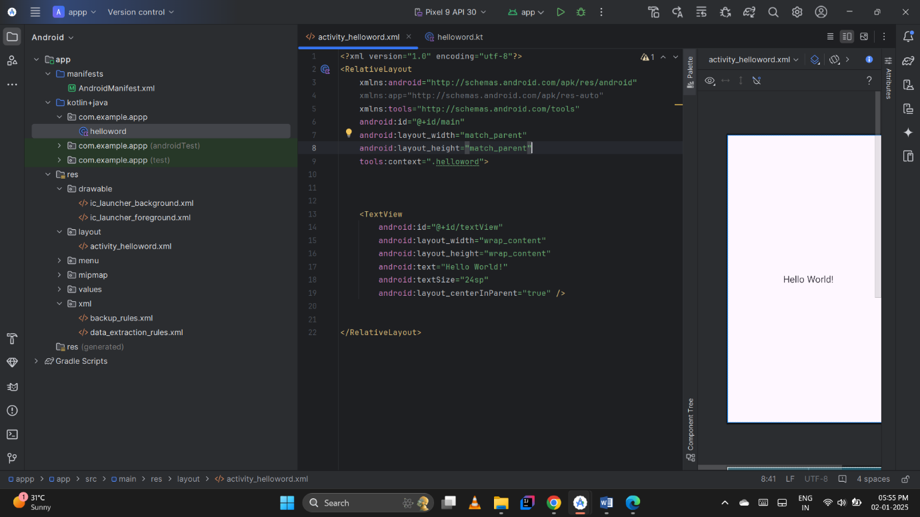

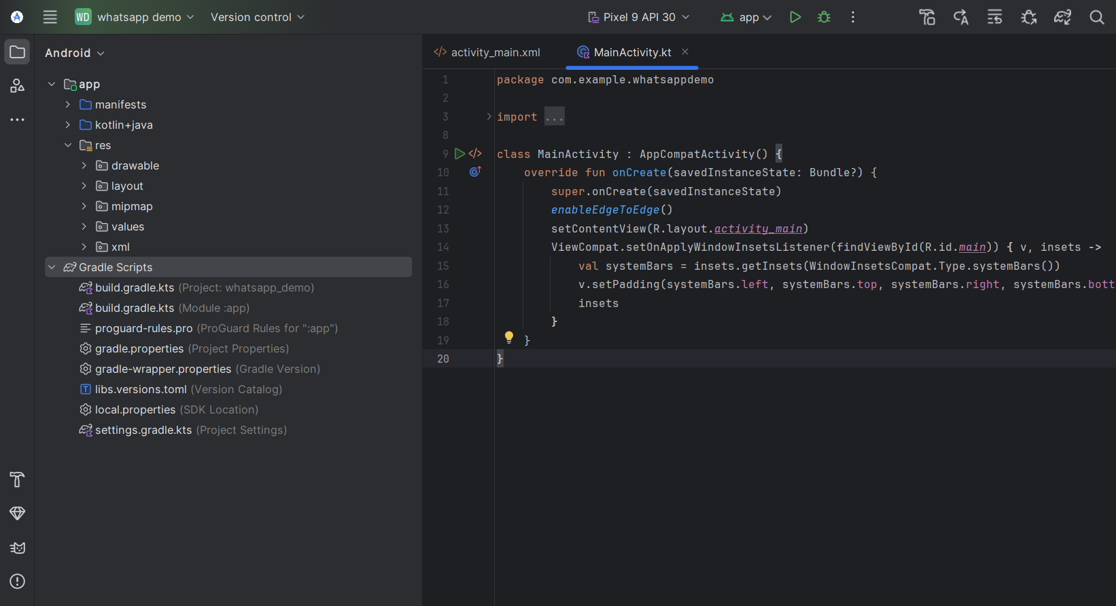

Structure :

App :

Android manifest

Res:

Drawable

Layout

Mipmap

Values

Xml

Gradle scripts :

App in android phone:

